|  |  |
| --- | --- |
| ­­­­ | **FPT ACADEMY INTERNATIONAL**  **FPT – APTECH COMPUTER EDUCATION** |

**Centre Name: ACE-HCMC-2-FPT.**

**Address: 590 Cach Mang Thang 8, District 3, Ho Chi Minh City, Viet Nam.**

**SHOE**

**MANAGEMENT**

|  |  |  |
| --- | --- | --- |
| **Supervisor:** | Hoang Duc Quang | |
| **Semester:** | 4 | |
| **Batch No:** | T1.1810.E0 | |
| **Group No:** | 5 | |
| **Order:** | **Full name** | **Roll No.** |
| 1. | Nguyen Huu Tung | Student1151428 |
| 2. | Bui Nguyen Hai | Student 1159262 |
| 3. | Nguyen Van Binh | Student1143789 |
| 4. | Nguyen Minh Thu | Student1122727 |

Month 09 Year 2020

This is to certify that

Mr. **Nguyen Huu Tung**

Mr. **Bui Nguyen Hai**

Mr. **Nguyen Van Binh**

Ms. **Nguyen Minh Thu**

Has successfully Designed & Developed

**eProject: Shoe Management**

Submitted by:

**Nguyen Huu Tung**

Date of Issue:

**26 – Aug – 2020**

Authorized Signature:

Table of Contents

PROBLEM DEFINITION 6

CUSTOMER REQUIREMENT SPECIFICATION 7

Staff 7

Admin 7

Hardware 8

Software 8

Expected release date 8

List of deliverables 8

PROJECT PLAN 9

TASK SHEET REVIEW 1 10

USE CASE 12

Employee 12

Administrator 13

DATA FLOW DIAGRAM (DFD) 14

Data flow diagram symbol 14

Context level DFD – 0 level 14

1st Level Admin Side DFD 15

SEQUENCE DIAGRAM 21

Login 21

Profile 22

Customer 23

Salary / Membership / Voucher / Report 24

Product 26

Import 27

E-R DIAGRAM 28

Entity Relationship Diagram 28

Database Diagram 30

Database table design 32

CLASS DIAGRAM & DESCRIPTION 36

Admin Class 38

Product Class 38

Customer Class 39

Import Class 39

Order Class 40

ALGORITHMS 41

Login 41

Admin 42

TASK SHEET REVIEW 2 43

GUI STANDARDS DOCUMENT 47

INTERFACE DESIGN DOCUMENT 48

Home page 48

Login 49

Reset password 50

Admin profile table 51

Create / Edit profile table 52

Admin / Discount / Voucher / Product table 55

Detail table 57

Create / Edit Discount table 59

Create / Edit Product table 61

Invoice table 64

TASK SHEET REVIEW 3 65

**REVIEW 1**

# PROBLEM DEFINITION

The objective of the system is to provide the facilities to all the people concerned with the shoe store management. From the management point of view, works can be done fast and more accurately.

The system also provides many kinds of features. Our main objectives for developing this project are giving below.

**PRODUCT MANAGEMENT.**

**SECURITY**

**ORDERS**

**WAREHOUSE MANAGEMENT**

**INCREASED OPERATIONAL EFFICIENCY.**

**INCREASED ACCURACY AND RELIABILITY.**

**IMPROVE MORAL.**

**REDUCE OPRATIONAL TIME.**

This project aims to develop a complete fully functional independent system with the intention of improving the productivity of the operations through speedy and accurate processing and efficient storage and retrieval of data.

The basic aim behind this project to provide a complete solution that manages the records of shoe store management.

# CUSTOMER REQUIREMENT SPECIFICATION

This project is aimed to develop “Shoe Store Management”. It is a web-based application, which is developed mainly for the staff to manage products, in, out, and report products through the system.

The site should have a menu categorizing required functionalities

* **Dasboard**
* **Product**
* **Admin**
* **Customer**
* **Report**

There should be logins as mentioned below:

## Staff

The staff will be the store manager who can log in with the username and password.

The staff can be:

* Change the password.
* Import and sell products
* Create the customer
* Create the report

## Admin

The admin has all the permission to view or edit any pages

The admin can perform all the admin functions as maintaining the policy records, product records, report records, etc.

## Hardware

* A minimum computer system that will help you access all the tools in the courses is a Pentium 166 or better.
* 128 Megabytes of RAM or better

## Software

* Java / Spring MVC
* Microsoft SQL Server
* Netbeans IDE 8.2 to 12.0
* Notepad ++ editor
* Java enables webserver
* JSP / Servlets Dev. Kit

## Expected release date

Release date: 28 Sep 2020.

## List of deliverables

Documentation

* User manual
* Install guide
* Database script and database backup file
* Project documents

Website

* Deployment website
* Source code

# PROJECT PLAN

After due consideration with the team members, we decided the important criteria should be developed:

Dynamic page with database includes 2 parts:

* + The sales page, including all products, will be sold.
  + The administration page, depending on the rights of the account will be displayed content.

# TASK SHEET REVIEW 1

|  |  |  |  |  |  |  |  |
| --- | --- | --- | --- | --- | --- | --- | --- |
| **Project Ref. No.: eProject / Shoe Management** | | **Project Title:** | **Activity Plan Prepared By:** | **Date of Preparation of Activity Plan:** | | | |
| **No.** | **Task** | **Actual Start Date** | **Actual Days** | **Assigned** | **Status** |
| 1 | Problem defintion | Shoe Management | Nguyen Huu Tung | 07/09/2020 | 1 | All member | Completed |
| 2 | Customer requirement specification | 07/09/2020 | 1 | All member | Completed |
| 2.1 | - Staff | 07/09/2020 | 1 | All member | Completed |
| 2.2 | - Admin | 07/09/2020 | 1 | All member | Completed |
| 2.3 | - Hardware | 09/09/2020 | 1 | All member | Completed |
| 2.4 | - Software | 09/09/2020 | 1 | All member | Completed |
| 2.5 | - List of deliverables | 09/09/2020 | 1 | All member | Completed |
| 3 | Project plan | 09/09/2020 |  | All member | Completed |

**REVIEW 2**

# USE CASE

## Employee



Figure 1.1. Show the Use-Case of the application for employee

## Administrator



Figure 1.2. Show the Use-Case of the application for administrator

# DATA FLOW DIAGRAM (DFD)

## Data flow diagram symbol

|  |  |
| --- | --- |
| **Symbol** | **Description** |
|  | **Data flow** – Data flow are pipelines through the packets of information flow. |
|  | **Procress:** A procress or task performed by the system |
|  | **Entity:** Entity are object of the system. A source or destination data of the system. |
|  | **Data Store:** A place whrere data to be stored |

## Context level DFD – 0 level



Figure 2.1. Level DFD for Shoe Management website project

## 1st Level Admin Side DFD

The Admin side DFD describe the functionality of Admin, Admin is a owner of the website. Admin can first add category of item and then add items by category wise. and admin can manage order and payment detail.



Figure 2.2. 1st Level – Admin Side Data Flow Diagram



Figure 2.3. 2nd Level – DFD for online shopping website project



Figure 2.4. 2nd Level – Admin side DFD for shoe management website project



Figure 2.5. 2nd Level – Admin side DFD for shoe management website project



Figure 2.5. 2nd Level – Admin side DFD for shoe management website project

**2nd level – Employee side Data flow Diagram**

The employee is all staff who operate input and sell the items on our website. User can first select product for buy, user must have to register in our system for purchase any item from our website. after register he can login to site and buy or sell item for customers.



Figure 3.1. 1st Level – Employee Side Data Flow Diagram



Figure 3.1. 2nd Level – Employee side DFD for online shopping website project

# SEQUENCE DIAGRAM

## Login



|  |  |  |
| --- | --- | --- |
| **Author** | Bui Nguyen Hai | |
| **Use case name** | Login | |
| **Actors** | Admin, Employee | |
| **Description** | User login to manage profiles, product, v.v… | |
| **Requirements** | User must login by username & password | |
| **Pre-conditions** |  | |
| **Post-conditions** | Success: Login successful  Failed: Login failed. Try to login again | |
|  | **Action** | **Response** |
| **Basic flow** | * Input username & password * Button submit | * Check username & password on database. |
| **Exception** | * Username & password cannot be blank * Min: 2 characters, max 20 characters | * Username or password cannot blank * The name is taken, try another please. |

## Profile



|  |  |  |
| --- | --- | --- |
| **Author** | Bui Nguyen Hai, Nguyen Van Binh | |
| **Use case name** | Edit profile | |
| **Actors** | Admin, Employee | |
| **Description** | Edit user information | |
| **Requirements** | User must login by username & password | |
| **Pre-conditions** |  | |
| **Post-conditions** | Success: Profile updated successful  Failed: Updated failed. Try to login again | |
|  | **Action** | **Response** |
| **Basic flow** | * User click “edit profile” button * Change user informations | * Redirect to edit profile page * Validate informations * Update to database |
| **Exception** | * Required: not null * Min: 2 characters, max 20 characters * Mobile: only number | Responde error if any form blank |

## Customer



|  |  |  |
| --- | --- | --- |
| **Author** | Bui Nguyen Hai, Nguyen Van Binh | |
| **Use case name** | Customer page | |
| **Actors** | Admin, Employee | |
| **Description** | View / Create / Edit / Disable | |
| **Requirements** | User must login by username & password | |
| **Pre-conditions** |  | |
| **Post-conditions** | Success: Successful  Failed: Failed. | |
|  | **Action** | **Response** |
| **Basic flow** | * User click “Customer” menu * Change user informations | * Redirect to edit profile page * Validate informations * Update to database |
| **Exception** | Validate all input form | Responde error if any form invalid |

## Salary / Membership / Voucher / Report



|  |  |  |
| --- | --- | --- |
| **Author** | Bui Nguyen Hai, Nguyen Minh Thu | |
| **Use case name** | Salary, report page | |
| **Actors** | Admin, Employee | |
| **Description** | View / Create | |
| **Requirements** | User must login by username & password | |
| **Pre-conditions** |  | |
| **Post-conditions** | Success: Successful  Failed: Failed. | |
|  | **Action** | **Response** |
| **Basic flow** | * User click to link on the menu * Change user informations | * Redirect to page * Validate informations * Update to database |
| **Exception** | Validate all input form | Responde error if any form invalid |

|  |  |  |
| --- | --- | --- |
| **Author** | Nguyen Huu Tung, Nguyen Van Binh | |
| **Use case name** | Membership, voucher page | |
| **Actors** | Admin, Employee | |
| **Description** | View / Create / Edit / Disable | |
| **Requirements** | User must login by username & password | |
| **Pre-conditions** |  | |
| **Post-conditions** | Success: Successful  Failed: Failed. | |
|  | **Action** | **Response** |
| **Basic flow** | * User click to link on the menu * Change user informations | * Redirect to page * Validate informations * Update to database |
| **Exception** | Validate all input form | Responde error if any form invalid |

## Product



|  |  |  |
| --- | --- | --- |
| **Author** | Bui Nguyen Hai, Nguyen Van Binh | |
| **Use case name** | Product, cart, order, invoice page | |
| **Actors** | Admin, Employee | |
| **Description** | View / Create / Edit / Disable | |
| **Requirements** | User must login by username & password | |
| **Pre-conditions** |  | |
| **Post-conditions** | Success: Successful  Failed: Failed. | |
|  | **Action** | **Response** |
| **Basic flow** | * User click to link on the menu * Change user informations | * Redirect to page * Validate informations * Update to database |
| **Exception** | Validate all input form | Responde error if any form invalid |

## Import



|  |  |  |
| --- | --- | --- |
| **Author** | Nguyen Huu Tung | |
| **Use case name** | Import, import check page | |
| **Actors** | Admin, Employee | |
| **Description** | View / Create / Edit / Disable | |
| **Requirements** | User must login by username & password | |
| **Pre-conditions** |  | |
| **Post-conditions** | Success: Successful  Failed: Failed. | |
|  | **Action** | **Response** |
| **Basic flow** | * User click to link on the menu * Change user informations | * Redirect to page * Validate informations * Update to database |
| **Exception** | Validate all input form | Responde error if any form invalid |

# E-R DIAGRAM

## Entity Relationship Diagram





## Database Diagram

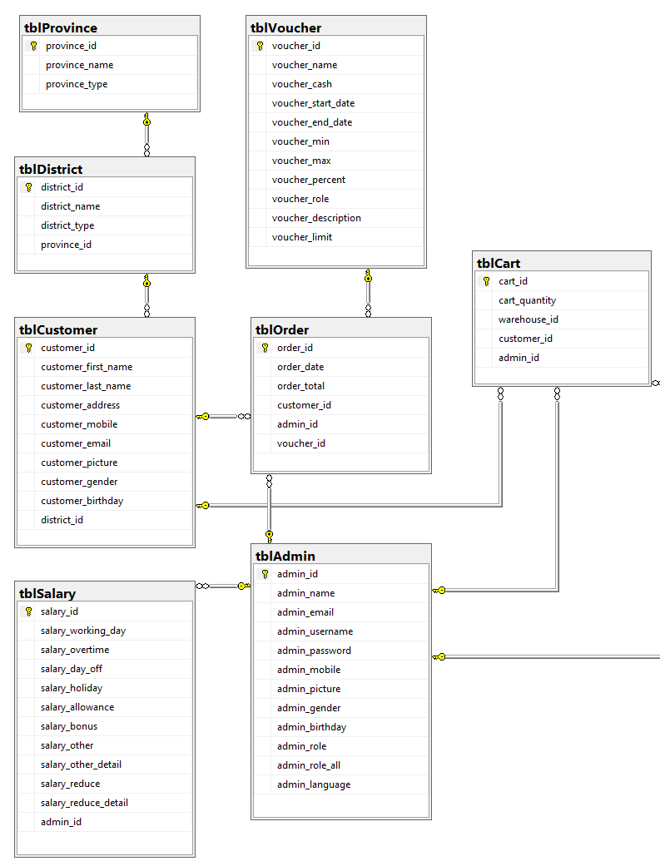

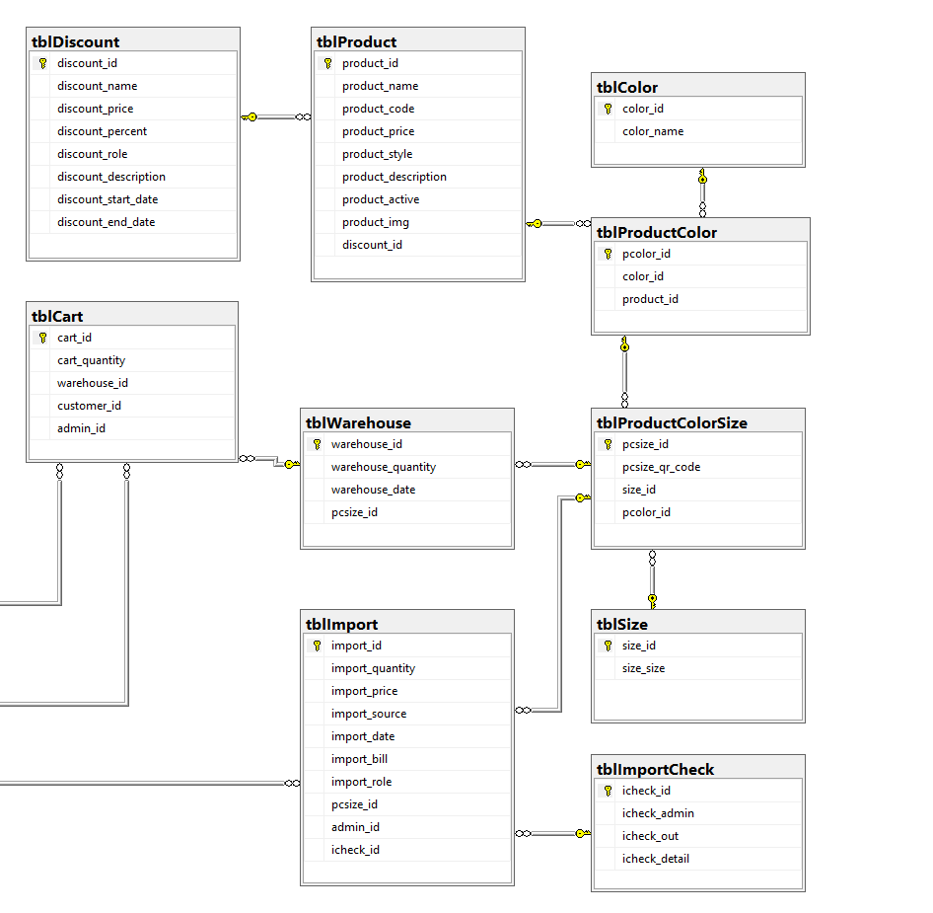

## Database table design

|  |  |  |  |
| --- | --- | --- | --- |
| **Table name** | **Field name** | **Data type** | **Key** |
| Admin | Admin_id | Int | Primary key |
| Admin_name | Nvarchar(100) |  |
| Admin_email | Nvarchar(150) |  |
| Admin_username | Varchar(100) |  |
| Admin_password | Nvarchar(100) |  |
| Admin_mobile | Varchar(20) |  |
| Admin_picture | Nvarchar(MAX) |  |
| Admin_gender | Int |  |
| Admin_birthday | Date |  |
| Admin_role | Int |  |
| Admin_role_all | Varchar(150) |  |
| Admin_language | Int |  |
| Cart | Cart_id | Int | Primary key |
| Cart_quantity | Int |  |
| Warehouse_id | Int | Foreign key |
| Customer_id | Int | Foreign key |
| Admin_id | In | Foreign key |
| Color | Color_id | Int | Primary key |
| Color_name | Nvarchar(50) |  |
| Customer | Customer_id | Int | Primary key |
| Customer_first_name | Nvarchar(100) |  |
| Customer_last_name | Nvarchar(100) |  |
| Customer_address | Nvarchar(MAX) |  |
| Customer_mobile | Varchar(20) |  |
| Customer_email | Nvarchar(150) |  |
| Customer_picture | Nvarchar(MAX) |  |
| Customer_gender | Int |  |
| Customer_birthday | Date |  |
| District_id | Int | Foreign key |
| Discount | Discount_id | Int | Primary key |
| Discount_name | Nvarchar(50) |  |
| Discount_price | Decimal(18,2) |  |
| discount_percent | Int |  |
| Discount_role | Int |  |
| Discount_description | Nvarchar(MAX) |  |
| Discount_start_date | Datetime |  |
| Discount_end_date | Datetime |  |
| District | District_id | Int | Primary key |
| District_name | Nvarchar(50) |  |
| District_type | Nvarchar(50) |  |
| Province_id | Int | Foreign key |
| Import | Import_id | Int | Primary key |
| Import_quantity | Int |  |
| Import_price | Decimal(18,2) |  |
| Import_source | Nvarchar(MAX) |  |
| Import_date | Datetime |  |
| Import_bill | Nvarchar(50) |  |
| Import_role | int |  |
| Pcsize_id | Int | Foreign key |
| Admin_id | Int | Foreign key |
| Icheck_id | Int | Foreign key |
| ImportCheck | Icheck_id | Int | Primary key |
| Icheck_admin | Int |  |
| Icheck_out | Int |  |
| Icheck_detail | Nvarchar(50) |  |
| Membership | Membership_id | Int | Primary key |
| Membership_detail | Nvarchar(150) |  |
| Membership_total | Int |  |
| Membership_percent_out | Int |  |
| Order | Order_id | Int | Primary key |
| Order_date | Datetime |  |
| Order_total | Decimal(18,2) |  |
| Customer_id | Int | Foreign key |
| Admin_id | Int | Foreign key |
| Voucher_id | Int | Foreign key |
| Product | Product_id | Int | Primary key |
| Product_name | Nvarchar(150) |  |
| Product_code | Nvarchar(50) |  |
| Product_price | Decimal(18,2) |  |
| Product_style | Nvarchar(50) |  |
| Product_description | Nvarchar(MAX) |  |
| Product_active | Int |  |
| Product_img | Nvarchar(MAX) |  |
| Discount_id | Int | Foreign key |
| ProductColor | Pcolor_id | Int | Primary key |
| Color_id | Int | Foreign key |
| Product_id | Int | Foreign key |
| Image_id | Int | Foreign key |
| ProductColorSize | Pcsize_id | Int | Primary key |
| Pcsize_qr_code | Nvarchar(MAX) |  |
| Size_id | Int | Foreign key |
| Pcolor_id | Int | Foreign key |
| Province | Province_id | Int | Primary key |
| Province_name | Nvarchar(50) |  |
| Province_type | Nvarchar(50) |  |
| Revenue | Revenue_id | Int | Primary key |
| Revenue_name | Nvarchar(150) |  |
| Revenue_detail | Nvarchar(MAX) |  |
| Revenue_month | Int |  |
| Revenue_year | Int |  |
| Revenue_total | Int |  |
| Salary | Salary_id | Int | Primary key |
| Salary_working_day | Decimal(18, 1) |  |
| Salary_overtime | Decimal(18, 1) |  |
| Day_off | Decimal(18, 1) |  |
| Salary_holiday | Decimal(18, 1) |  |
| Salary_allowance | Decimal(18, 2) |  |
| Salary_bonus | Decimal(18, 2) |  |
| Salary_other | Decimal(18, 2) |  |
| Salary_other_detail | Nvarchar(150) |  |
| Salary_reduce | Decimal(18, 2) |  |
| Salary_reduce_detail | Nvarchar(150) |  |
| Admin_id | Int | Foreign key |
| Size | Size_id | Int | Primary key |
| Size_size | Int |  |
| Voucher | Voucher_id | Int | Primary key |
| Voucher_name | Nvarchar(50) |  |
| Voucher_cash | Int |  |
| Voucher_start_date | Datetime |  |
| Voucher_end_date | Datetime |  |
| Voucher_min | Int |  |
| Voucher_max | Int |  |
| Voucher_percent | Int |  |
| Voucher_role | Int |  |
| Voucher_description | Nvarchar(MAX) |  |
| Voucher_limit | Int |  |
| Warehouse | Warehouse_id | Int | Primary key |
| Warehouse_quantity | Int |  |
| Warehouse_date | Datetime |  |
| Pcsize_id | Int | Foreign key |

# CLASS DIAGRAM & DESCRIPTION

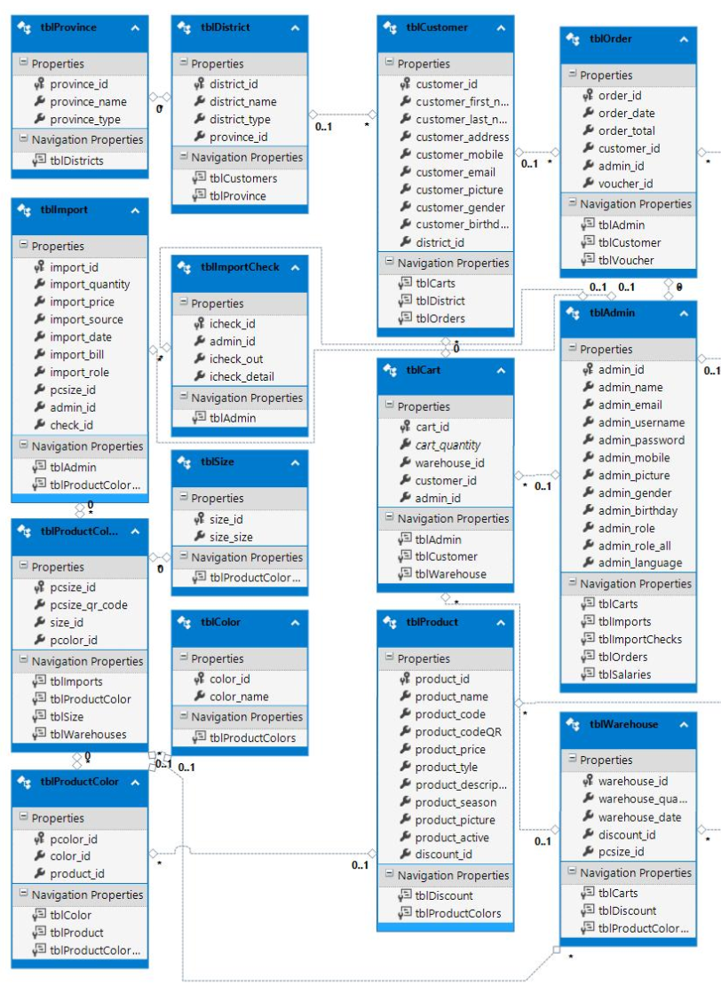

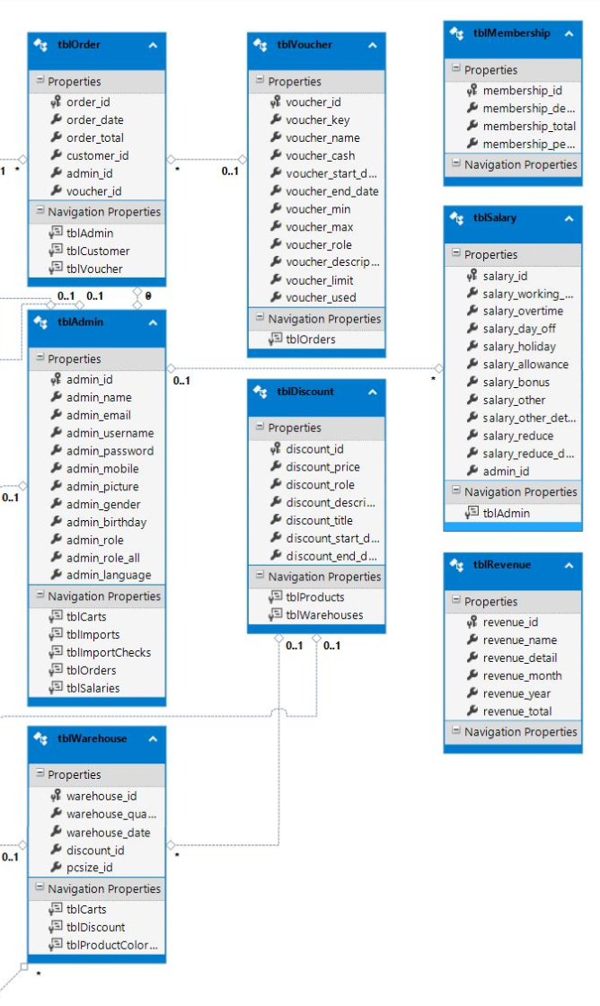

## Admin Class

|  |  |
| --- | --- |
| **Attributes** | **Description** |
| Name | Full name |
| Email | Email of employee or admin |
| Username | Username of employee or admin |
| Password | Password of employee or admin |
| Mobile | Mobile of employee or admin |
| Picture | Picture of user |
| Gender | Male or Female |
| Birthday | The day of birth |
| **Methods** | **Description** |
| Login | Login to mange the website |
| Change password | Change password |
| Edit profile | Update information User |

## Product Class

|  |  |
| --- | --- |
| **Attributes** | **Description** |
| Name | Product name |
| Code | Product code |
| Price | Price for every product |
| Style | Male or Female |
| Description | Describe information about product |
| Img | Picture of product |
| Color | Product color |
| Size | Size of product |
| **Methods** | **Description** |
| Create | Set a new product |
| Update | Update information about the product |
| Disable | Disable product |
| View | Show all the information the product |
| Search, Filter | Search and fillter any product want to check. |

## Customer Class

|  |  |
| --- | --- |
| **Attributes** | **Description** |
| Firstname | First name |
| Lastname | Last name |
| Address | Address of customer |
| Mobile | The phone of the customer |
| Email | Email of the customer |
| Picture | Picture of the customer |
| Gender | Male or Female |
| Birthday | The day of the birth |
| **Methods** | **Description** |
| Create | Create a new customer |
| Update | Update information about the customer |
| Disable | Disable the customer |
| View | Show all the information the customer |

## Import Class

|  |  |
| --- | --- |
| **Attributes** | **Description** |
| Name | Product name |
| Color | Product color |
| Size | Product size |
| Quantity | Describe amount number of the product |
| Price | Product price to sell |
| Date | The day when add to the warehouse |
| Bill | The invoice when add to the warehouse |
| **Methods** | **Description** |
| Create | Create a new product import to warehouse |
| Disable | Disable the customer |
| View | Show all the information the product in warehouse |

## Order Class

|  |  |
| --- | --- |
| **Attributes** | **Description** |
| Date | The day of order product |
| Total | Total product buy in a invoice |
| Customer | The customer name who buy the products |
| Admin | The user sell products for the customer |
| Voucher | Discount for every product |
| **Methods** | **Description** |
| Create | Create a new product import to warehouse |
| View | Show all the information the product in warehouse |

# ALGORITHMS

## Login



## Admin



# TASK SHEET REVIEW 2

|  |  |  |  |  |  |  |  |
| --- | --- | --- | --- | --- | --- | --- | --- |
| **Project Ref. No.: eProject / Shoe Management** | | **Project Title:** | **Activity Plan Prepared By:** | **Date of Preparation of Activity Plan:** | | | |
| **Sr. No.** | **Task** | **Actual Start Date** | **Actual Days** | **Assigned** | **Status** |
| 1 | Use case | Shoe Management | Nguyen Huu Tung | 11/09/2020 | 1 | All member | Completed |
| 1.1 | - Employee | 11/09/2020 | 1 |  | Completed |
| 1.2 | - Administrator | 11/09/2020 | 1 |  | Completed |
| 2 | Data flow diagram (DFD) | 12/09/2020 | 1 | All member | Completed |
| 2.1 | - DFD Symbol | 12/09/2020 | 1 |  | Completed |
| 2.2 | - Context level DFD | 12/09/2020 | 1 |  | Completed |
| 2.3 | - 1st Level Admin Side DFD | 12/09/2020 | 1 |  | Completed |
| 2.4 | - 2nd level – Employee side Data flow Diagram | 12/09/2020 | 1 |  | Completed |
| 3 | Sequence diagram | 13/09/2020 | 1 |  | Completed |
| 3.1 | - Login page | 13/09/2020 | 1 | Hai | Completed |
| 3.2 | - Profile page | 13/09/2020 | 1 | Hai | Completed |
| 3.3 | - Customer page | 13/09/2020 | 1 | Thu | Completed |
| 3.4 | - Salary, membership, voucher, report page | 13/09/2020 | 1 | Hai, Tung, Binh, Thu | Completed |
| 3.5 | - Product page | 13/09/2020 | 1 | Hai | Completed |
| 3.6 | - Import page | 13/09/2020 | 1 | Tung | Completed |
| 4 | E-R Diagram | 15/09/2020 | 1 |  | Completed |
| 4.1 | Entity relationship diagram | 15/09/2020 | 1 | Tung, Hai | Completed |
| 4.2 | Database table design | 15/09/2020 | 1 | Tung, Hai | Completed |
| 4.3 | Database diagram | 15/09/2020 | 1 | Tung | Completed |
| 5 | Class diagram | 15/09/2020 | 1 | Hai | Completed |
| 6 | Algorithms | 15/09/2020 | 1 | Binh, Thu | Completed |
| 6.1 | Login | 15/09/2020 | 1 | Binh, Thu | Completed |
| 6.2 | Admin | 15/09/2020 | 1 | Binh, Thu | Completed |

**REVIEW 3**

# GUI STANDARDS DOCUMENT



# INTERFACE DESIGN DOCUMENT

## Home page

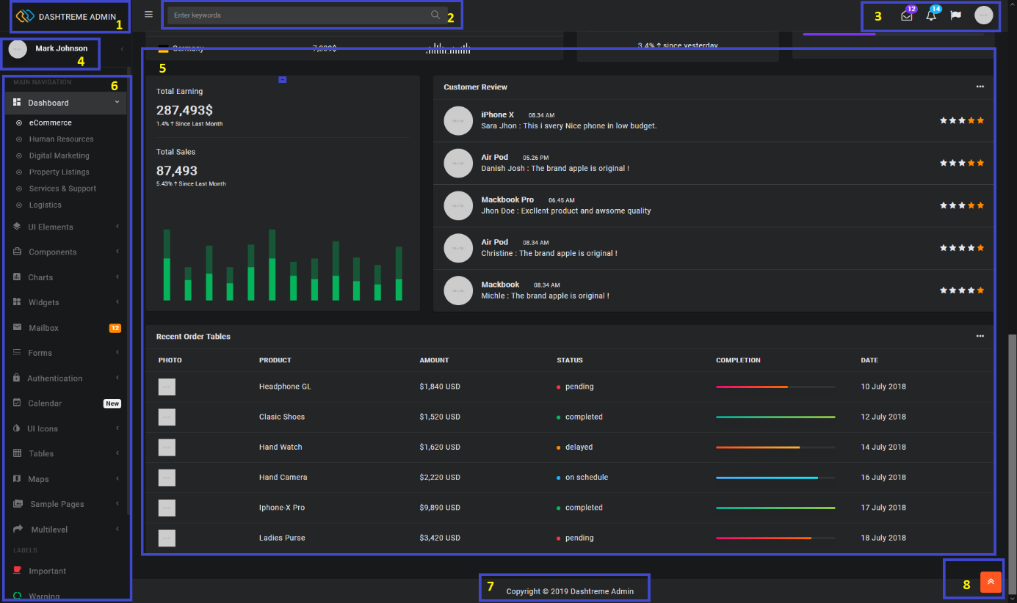

|  |  |  |  |  |  |  |
| --- | --- | --- | --- | --- | --- | --- |
| **No.** | **Field name** | **Type** | **Validation** | **Event** | **Description** | **Status** |
| 1 | Logo | Button |  | Click | Go to homepage | Enable |
| 2 | Search | Input text |  | Type | Search information | Enable |
| 3 | Top menu | Button |  | Click | Go to page | Enable |
| 4 | Profile | Button |  | Click | Go to profile page | Enable |
| 5 | Main content | Page |  |  |  | Enable |
| 6 | Main menu | Button |  | Click | Go to pages | Enable |
| 7 | Footer | Text |  | Text |  | Static |
| 8 |  | Button |  | Click | Go to top page | enable |

## Login

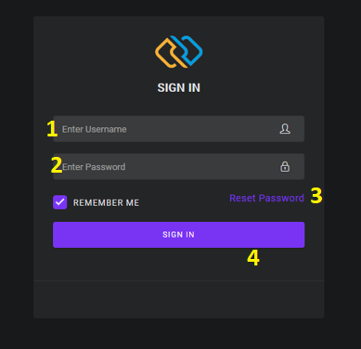

|  |  |  |  |  |  |  |
| --- | --- | --- | --- | --- | --- | --- |
| **No.** | **Field name** | **Type** | **Validation** | **Event** | **Description** | **Status** |
| 1 | Username | Input text |  | Type | Enter your username | Enable |
| 2 | Password | Input text |  | Type | Enter your password | Enable |
| 3 | Reset password | Button |  | Click | Fogot password | Enable |
| 4 | Login | Button |  | Click | Go to page | Enable |

## Reset password

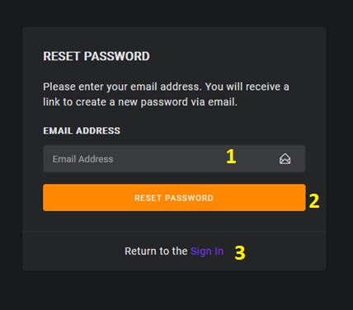

|  |  |  |  |  |  |  |
| --- | --- | --- | --- | --- | --- | --- |
| **No.** | **Field name** | **Type** | **Validation** | **Event** | **Description** | **Status** |
| 1 | Email | Input text |  | Type | Enter your email | Enable |
| 2 | Reset password | Button |  | Click | Submit to reset password | Enable |
| 3 | Return to Sign In | Button |  | Click | Go to login page | Enable |

## Admin profile table

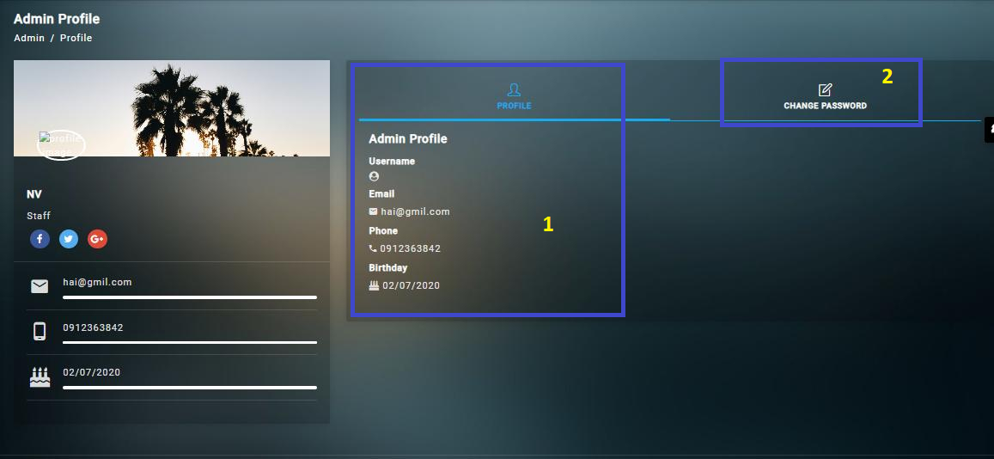

|  |  |  |  |  |  |  |
| --- | --- | --- | --- | --- | --- | --- |
| **No.** | **Field name** | **Type** | **Validation** | **Event** | **Description** | **Status** |
| 1 | Profile Information |  |  |  |  | Enable |
| 2 | Change password | Button |  | Click | Click to change password | Enable |

## Create / Edit profile table

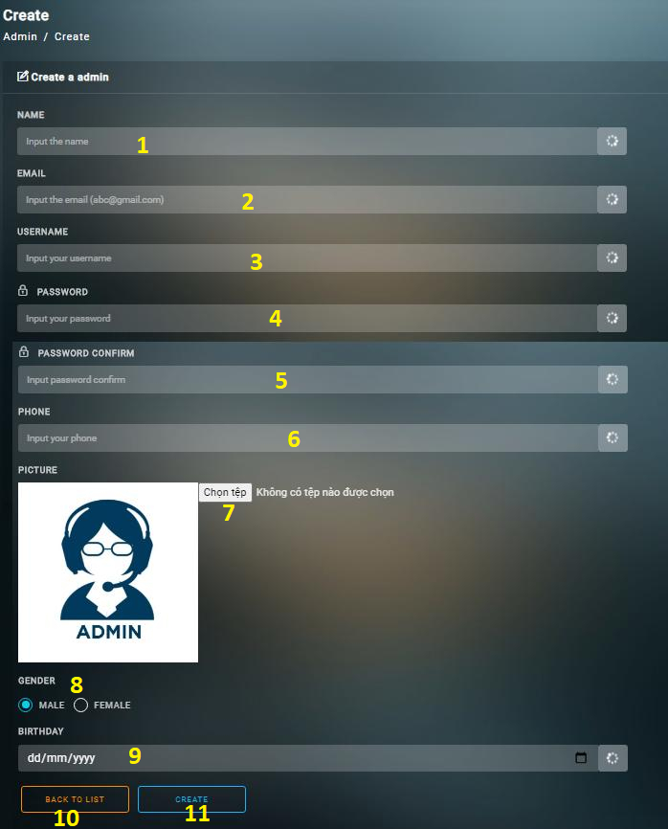

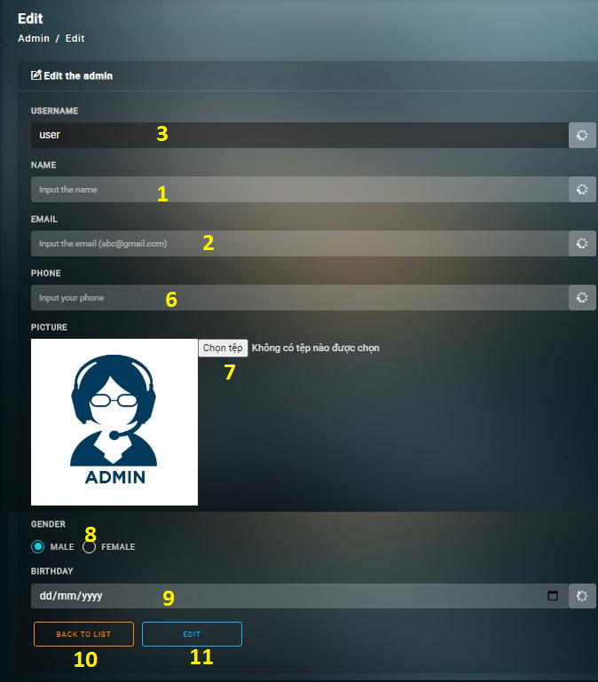

|  |  |  |  |  |  |  |
| --- | --- | --- | --- | --- | --- | --- |
| **No.** | **Field name** | **Type** | **Validation** | **Event** | **Description** | **Status** |
| 1 | Name | Input text | Can not blank | Type | Input the name | Enable |
| 2 | Email | Input text | Request follow the email format | Type | Input the email | Enable |
| 3 | Username | Input text | From 2 -20 characters | Type | Input the username | Enable |
| 4 | Password | Input text | Min 6 characters | Type | Type your password | Enable |
| 5 | Password confirm | Input text |  | Type | Type your password confirm | Enable |
| 6 | Phone | Input text | Only number | Type | Type the phone | Enable |
| 7 | Picture | Button |  | Click | Choose the image | Enable |
| 8 | Gender | Radio button |  | Click | Choose your gender | Enable |
| 9 | Birthday | Input text | Only number, follow the format | Type | Input the birthday | Enable |
| 10 | Back | Button |  | Click | Cancel the page | Enable |
| 11 | Create | Button |  | Click | Submit the form | Enable |

## Admin / Discount / Voucher / Product table

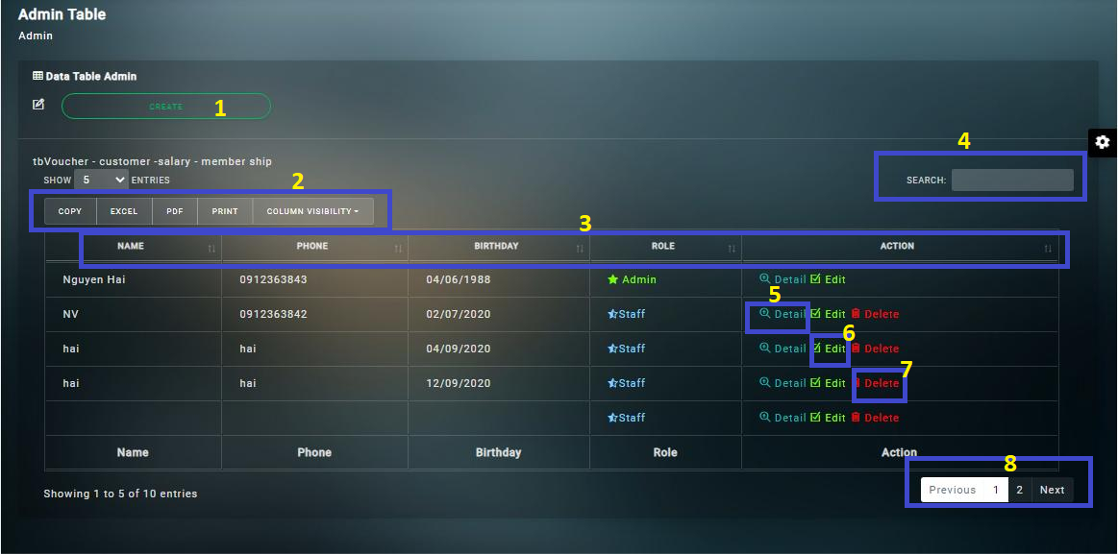

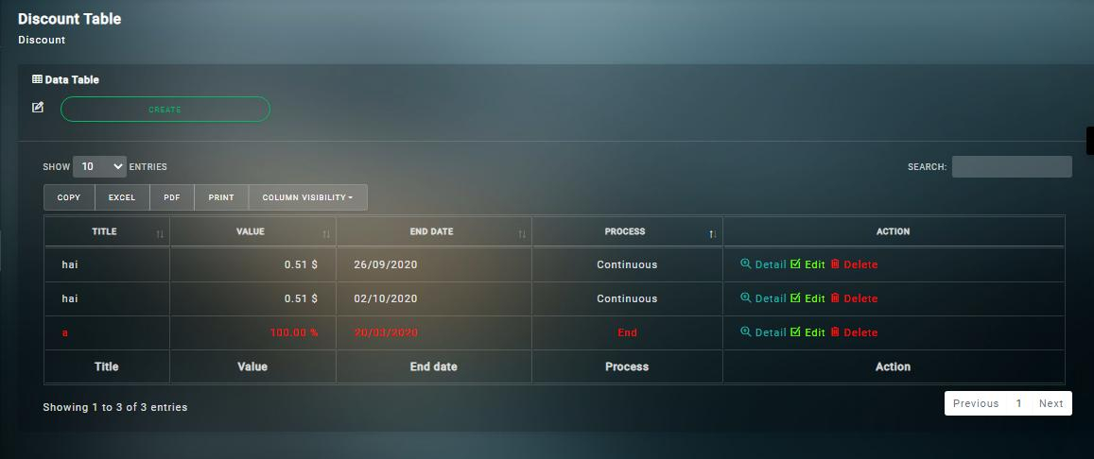

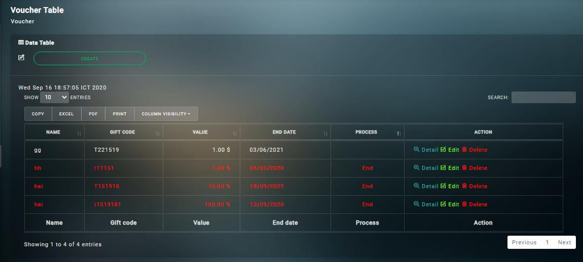

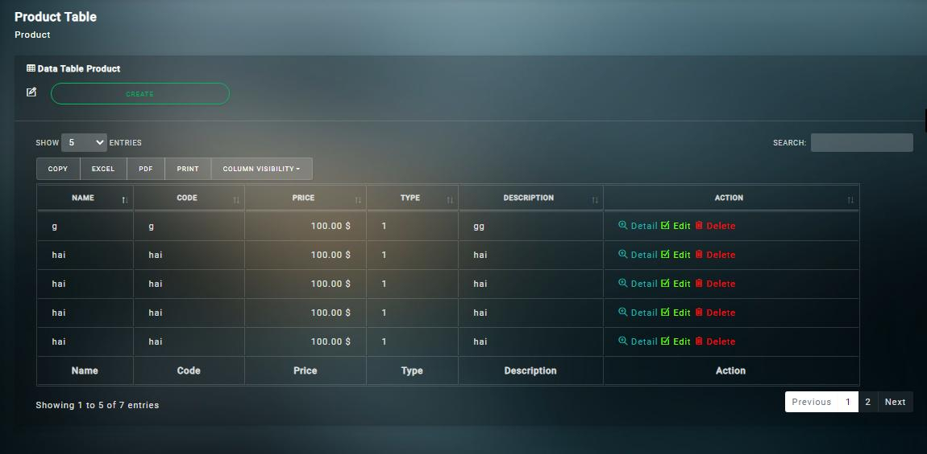

|  |  |  |  |  |  |  |
| --- | --- | --- | --- | --- | --- | --- |
| **No.** | **Field name** | **Type** | **Validation** | **Event** | **Description** | **Status** |
| 1 | Create | Button |  | Click | Create new user | Enable |
| 2 | Export to file | Button |  | Click | Export to file or print | Enable |
| 3 | Filter | Button |  | Click | Filter data | Enable |
| 4 | Search | Input text |  | type | Search data | Enable |
| 5 | Detail | Button |  | Click | Go to detail page | Enable |
| 6 | Edit | Button |  | Click | Go to edit page | Enable |
| 7 | Delete | Button |  | Click | Disable data | Enable |
| 8 | Page | Button |  | Click | View page | Enable |

## Detail table

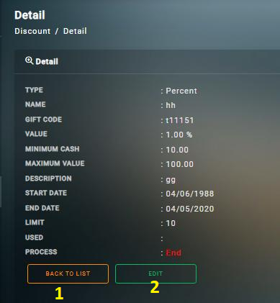

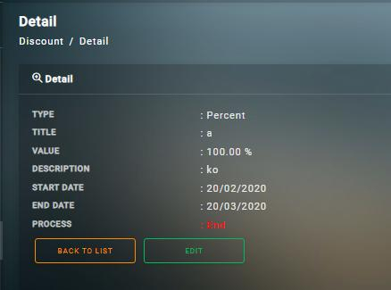

|  |  |  |  |  |  |  |
| --- | --- | --- | --- | --- | --- | --- |
| **No.** | **Field name** | **Type** | **Validation** | **Event** | **Description** | **Status** |
| 1 | Back | Button |  | Click | Cancel the page | Enable |
| 2 | Edit | Button |  | Click | Edit the form | Enable |

## Create / Edit Discount table

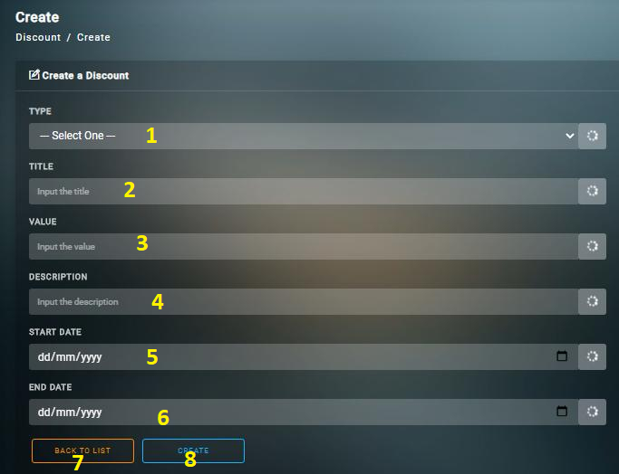

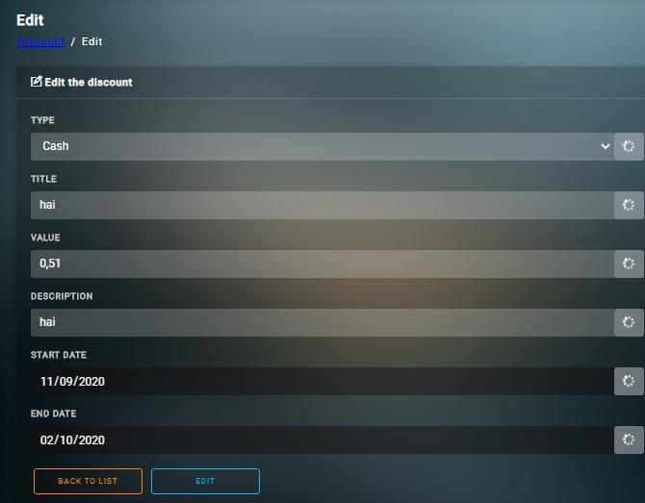

|  |  |  |  |  |  |  |
| --- | --- | --- | --- | --- | --- | --- |
| **No.** | **Field name** | **Type** | **Validation** | **Event** | **Description** | **Status** |
| 1 | Type | Select |  | Select | Choose discount type | Enable |
| 2 | Title | Input text |  | Type | Input the title | Enable |
| 3 | Value | Input text |  | Type | Input value want to discount | Enable |
| 4 | Description | Input text |  | Type | Description about discount information | Enable |
| 5 | Start date | Input text |  | Type | Type the day to start | Enable |
| 6 | End date | Input text |  | Type | Type the day to end | Enable |
| 7 | Back | Button |  | Click | Cancel the form | Enable |
| 8 | Create / Edit | Button |  | Click | Submit the form | Enable |

## Create / Edit Product table

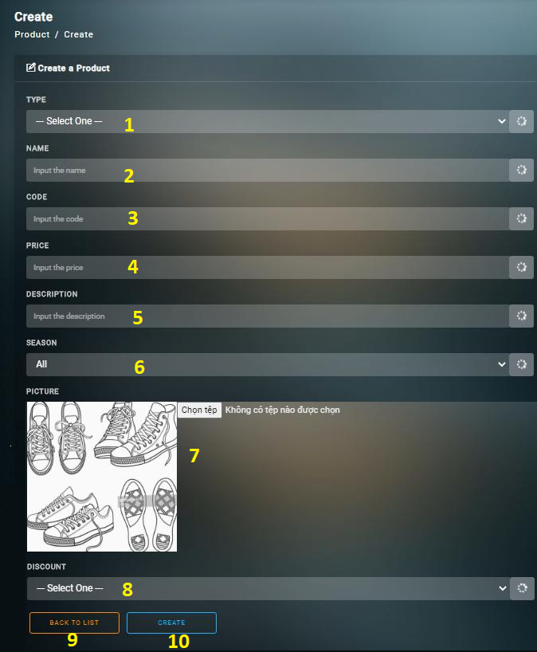

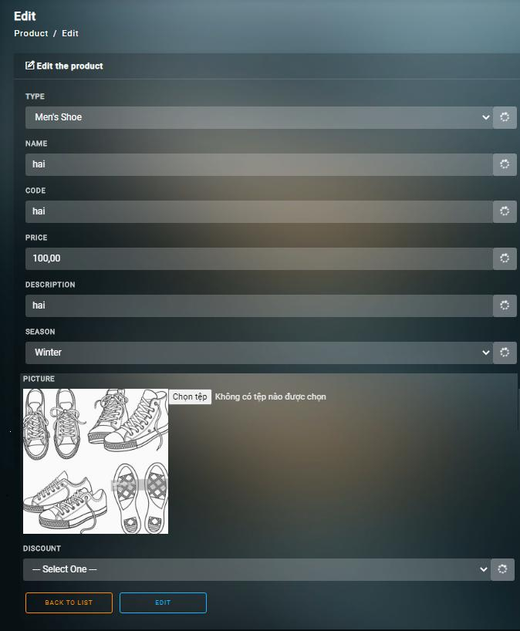

|  |  |  |  |  |  |  |
| --- | --- | --- | --- | --- | --- | --- |
| **No.** | **Field name** | **Type** | **Validation** | **Event** | **Description** | **Status** |
| 1 | Type | Select |  | Select | Choose product type | Enable |
| 2 | Name | Input text |  | Type | Input name of the product | Enable |
| 3 | Code | Input text |  | Type | Product code | Enable |
| 4 | Price | Input text | Only number | Type | Price of product | Enable |
| 5 | Description | Input text |  | Type | Decribe the product information | Enable |
| 6 | Season | Select |  | Select | Choose the season | Enable |
| 7 | Picture | Button |  | Click | Insert the image for product | Enable |
| 8 | Discount | Select |  | Click | Choose the discount for product | Enable |
| 9 | Back | Button |  | Click | Cancel the form | Enable |
| 10 | Create / Edit | Button |  | Click | Submit the form | Enable |

## Invoice table

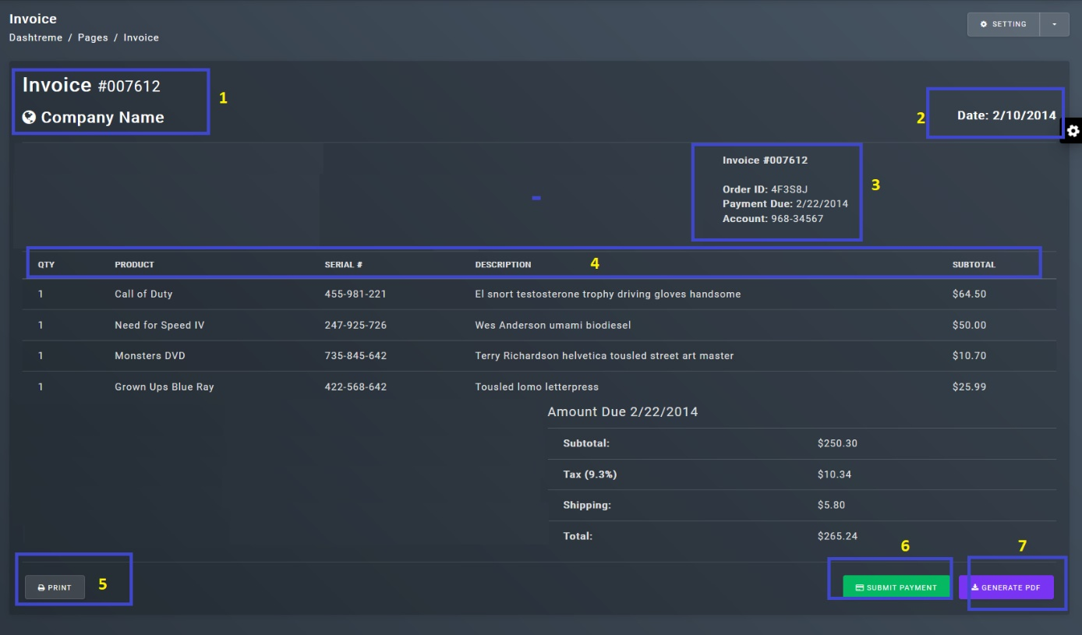

|  |  |  |  |  |  |  |
| --- | --- | --- | --- | --- | --- | --- |
| **No.** | **Field name** | **Type** | **Validation** | **Event** | **Description** | **Status** |
| 1 | Invoice, customer name | Text |  |  | Customer name | Enable |
| 2 | Date | Text |  |  | Invoice date | Enable |
| 3 | Title | Text |  |  | Can filter on title | Enable |
| 4 | Page | Button |  | Click | Go to page | Enable |
| 5 | Print | Button |  | click | Print invoice | Enable |
| 6 | Submit | Button |  | Click | Go to product page | Enable |
| 7 | Export to pdf | Button |  | Click | Export to pdf file | Enable |

# TASK SHEET REVIEW 3

|  |  |  |  |  |  |  |  |  |
| --- | --- | --- | --- | --- | --- | --- | --- | --- |
| **Project Ref. No.: eProject / Shoe Management** | | **Shoe Management** | **Nguyen Huu Tung** | **Date of Preparation of Activity Plan:** | | | | |
| **Sr. No.** | **Task** | **Actual Start Date** | | **Actual Days** | **Assigned** | **Status** |
| 1 | Build database | 03/09/2020 | | 1 | Tung, Hai | Completed |
| 2 | Create database | 03/09/2020 | | 1 | Tung | Completed |
| 3 | Admin | 17/09/2020 | | 2 |  | Processing |
| 3.1 | - Login page |  | | 1 | Hai | Processing |
| 3.2 | - Reset password page |  | | 1 | Hai | Processing |
| 4 | Customer | 19/09/2020 | | 1 | Thu | Processing |
| 4.1 | - Customer page |  | |  | Thu | Processing |
| 4.2 | - Province page |  | | 0.5 | Thu | Processing |
| 4.3 | - District page |  | | 0.5 | Thu | Processing |
| 5 | Salary page | 20/09/2020 | | 1 | Hai | Processing |
| 6 | Order | 21/09/2020 | | 3 | Binh | Processing |
| 6.1 | - Order pages |  | | 1 | Binh | Processing |
| 6.2 | - Cart page |  | | 1 | Binh | Processing |
| 6.3 | - Voucher page |  | | 0.5 | Binh | Processing |
| 6.4 | - Discount page |  | | 0.5 | Binh | Processing |
| 7 | Product | 24/09/2020 | | 3 | Hai | Processing |
| 7.1 | - Product page |  | | 1 | Hai | Processing |
| 7.2 | - Color page |  | | 1 | Hai | Processing |
| 7.3 | - Size page |  | | 1 | Hai | Processing |
| 8 | Warehouse page | 27/09/2020 | | 1 | Tung | Processing |
| 9 | Import | 28/09/2020 | | 1 | Tung | Processing |
| 9.1 | - Import page |  | | 1 | Tung | Processing |
| 9.2 | - Import check page |  | | 1 | Tung | Processing |
| 10 | Dashboard page |  | 30/09/2020 | | 1 | Thu | Processing |
| 11 | Test code, design, field |  | 30/09/2020 | | All times | All teams | Processing |
| 12 | Test validation |  | 30/09/2020 | | All times | All teams | Processing |
| 13 | Write documents |  |  | | Base on schedule | Tung | Completed |
| **Date:** | | | | | | | | | |
| Signature of Instructor:  **Hoang Duc Quang** | | | | | Signature of team leader:  **Nguyen Huu Tung** | | | | |